**Magnetic Field Energy Stored in a Coil**

**Pre-lab questions**

1. What is the goal of this experiment? What physics and general science concepts does this activity demonstrate to the student?
2. What is an expression of Faraday’s law for the electromotive force induced in a coil of wire?
3. What is an expression for the magnetic energy stored in a coil of wire?
4. How does the electromotive force (or voltage) relate to potential energy?

The goal of this experiment is to help understand how an inductor (coil of wire) stores magnetic energy. To do this, we need to find the self-inductance *L*of the coil by measuring and graphing its voltage vs. time response in an LR-circuit to evaluate its characteristic time constant $τ$,and evaluate the magnetic field energy stored in the coil.

**Introduction**

A magnetic field is a force field that can act on a moving electric charge. Electric charges moving through a magnetic field will separate under the action of the magnetic force, having work done on them, and produce the electromotive force, ε. Electromotive force (emf)is a measure of the energy per unit charge of these separated charges that may then form an electric current. This energy is acquired from the magnetic field in accord with the law of the conservation of energy. So, the magnetic field is a physical field that has energy.

What is magnetic field energy?

According to Ampere’s law, any electric current *i*produces a magnetic field, **B**. When this magnetic field passes through some surface **A** (real or virtual), it has a magnetic flux through that surface $Φ=B∙A$. If the current *i* is changing, the magnetic field it produces **B**(*t*) is changing also and, in turn, changes the magnetic flux Φ(*t*). This surface **A** may happen to be bounded by a loop of metal wire, containing electric charges free to move. Faraday’s law says a changing magnetic flux induces an emf ***ε***(and resulting current *I* in the wire loop)**.** Hence, if current *i* is changing it will induce emf ***ε***Mas a result of the change in magnetic field which this current produced. Taken together, Ampere’s law and Faraday’s law show there is a direct proportionality between the electric current and the resulting magnetic flux it produces.

$ε_{M}=-\frac{∆Ф}{∆t}=-\frac{∆(Ф)}{∆t}=-\frac{∆(M i)}{∆t}=-M\frac{∆i}{∆t}$ (1)

The coefficient of proportionality between current and the magnetic flux produced by this current is called inductance, $M=Φ/i$. When a current flow in one wire produces a magnetic flux through a different wire loop, it is called mutual inductance. When the current produces a magnetic flux in the wire loop the current is flowing through, it is called self-inductance $L=\frac{Ф}{I}$**.** For a coil with N turns, $L=N \frac{Ф}{I}$ (2)

The units for inductance are: [*L*] *= Tesla·m2/A = Weber/A = Henry*(*H*)

For the case of self-inductance, the coefficient of proportionality *L* replaces *M* in Eqn. (1):

$ε_{L}=-N\frac{∆Ф}{∆t}=-\frac{∆(N Ф)}{∆t}=-\frac{∆(L I)}{∆t}=-L\frac{∆I}{∆t}$ (3)

The emf of self-inductance generates an induced current that opposes the change of the current going through the coil, which is the meaning of the minus sign in Eqn. (3).

When the current going through a circuit with a coil is constant, the coil is “invisible” in the sense of Faraday’s law and back emf, only the resistance of the coil plays a noticeable role. But when the current changes, there is an emf induced in the coil that results from the changing magnetic field energy. But either way, a coil of inductance *L* will store magnetic field energy.

The magnetic energy stored in a coil depends on the coil inductance and the square of the current passing through the coil:

$U_{M}=\frac{1}{2} L{ I}^{2}$ (4)

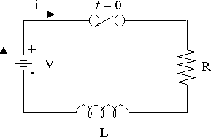An electric circuit with an inductor is called anLR-circuit, whether it contains a separate, explicit resistor or not. This is because any inductor *L* also has an internal resistance *R*, as shown on the diagram below.

Figure 1. Inductor in a DC circuit.

We can use Kirchoff’s Laws to predict what current is in a circuit with an inductor when it is connected to a battery of voltage *V*.

1. When the switch is closed (turning on the current), the current changes from zero to some value *I*(*t*)causing the self-induction emf *εL*in the inductor *L.*This emf *εL*is in opposite direction to the basic current *I*(*t*). Applying the Kirchhoff’s loop rule to the circuit: $I(t) ·R= V – ε_{L}$

Solving this equation for the current: $I(t) =\frac{V}{R} – \frac{ ε_{L}}{R} = I_{o}- i(t)$ (5)

where $I_{o}=V/R$ is the maximum, steady current from the battery, $i(t)$ is the time-dependent induced current of self-induction which falls off with time exponentially:

$$i=I_{0}{ e}^{-\frac{t}{τ}}$$

The resulting current in the circuit has two components, according to Eqn. (5): the steady current from the battery *Io* and the time-dependent current *i*(*t*) of self-induction: $I=I_{0} (1-e^{-\frac{t}{τ}})$ (6)

In this equation, *τ* is the time constant that depends on the parameters of coil - its inductance *L* and resistance *R*.:

$τ=L/R$ (6)

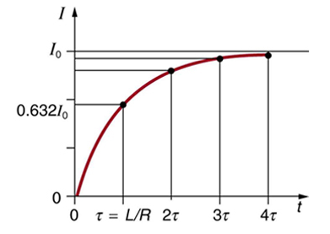When time *t* = $τ$, then current $I(τ)=0.63 I_{0}$, so $τ$ is the time required for the current to reach 63% of its maximum value, as shown in Figure 2.

Figure 2. Current through the coil when the switch is closed, current is turning on.

The larger the inductance *L*, the longer is the time constant *τ*. If an iron core is inserted into the coil, it will increase the inductance significantly. The resulting jump in the time constant will cause the current in the circuit to increase more slowly.

1. When opening the switch (turning off the current), current in the circuit changes from the maximum value of *I*0 to zero producing an emf of self-induction *εL*in the inductor *L****.*** Now the induced current *i*(*t*)changes direction to the opposite of what it was when the current was being turned on (still opposing the direction of change), and continues to flow supporting the vanishing current in the circuit. So, the inductor resists any sudden change in current due to the magnetic energy stored in the coil. When the switch is opened and current turns off, the induced current continues in a circuit for a short period of time:

$I=i=I_{0}{ e}^{-\frac{t}{τ}}$ (6)

Now the time constant $τ=\frac{L}{R}$ is the time for the current in the circuit to decrease to 37% of its original value after the switch was opened and the circuit was disconnected from the battery, as shown in Fig. 3.

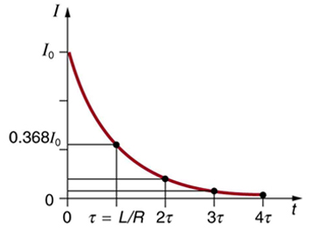 Figure 3. Current through the coil when the switch is opened, turning the current off.

We can see that there is always some “reaction time” for the current when the coil is turned on or off to the external source of energy. This reaction time is due to the energy stored in magnetic field of the coil.

**Equipment:** Pasco 850 Interface, voltage sensor, AC/DC Electronics Lab (inductor coil, iron core, 10 Ω resistor), connecting wires

**Experiment**

In this experiment, you will graph the VOLTAGE versus time for a 10 Ω resistor in series with the wire coil on the AC/DC Electronics Lab (as a monitor of the current in the coil) using the Pasco 850 Interface and the voltage sensor. The Capstone software with the 850 interface is used to precisely measure and simultaneously plot a graph of voltage vs. time when a “switch” is closed and opened, as illustrated in Figures 2 and 3. We can use the known resistance *R* of the resistor on the board to calculate the current, *I*(*t*)= *V*(*t*)/*R*.

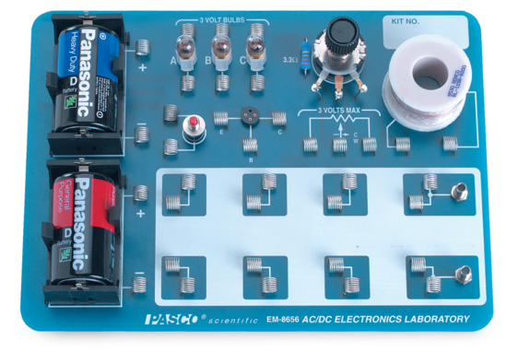

**Experimental setup and procedure**

1. 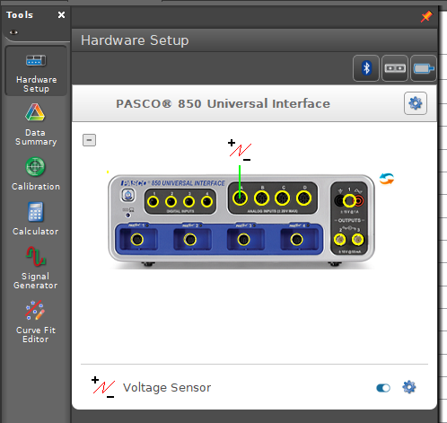Connect the voltage sensor plug into analog interface channel “A”. Attach the voltage sensor leads to either side of the 10 Ω resistor.
2. Wire circuit from ground to the base of the 10 Ω resistor, and then from the resistor to the inductor. Wire from red signal generator port to the other side of the inductor.
3. Measure voltage (PASCO voltage sensor) across the 10 Ω resistor on the circuit board. Increase the sample rate to 40 kHz.
4. A square wave voltage function will act as a repeating “switch.” Set up the square wave function generator in Capstone: Set the waveform to “Square,” the frequency to 1 Hz, phase shift = 0, and amplitude = 1.0 V.

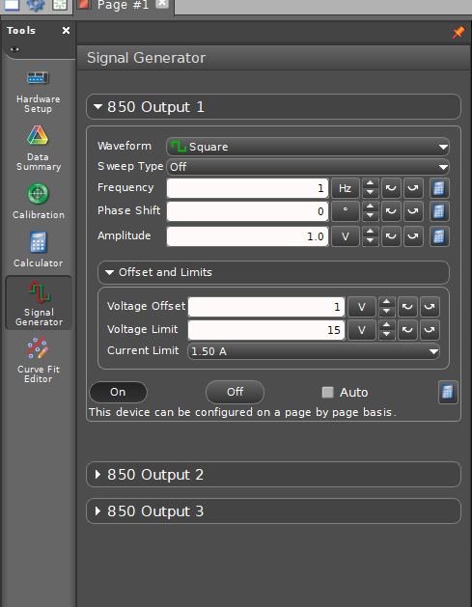

1. 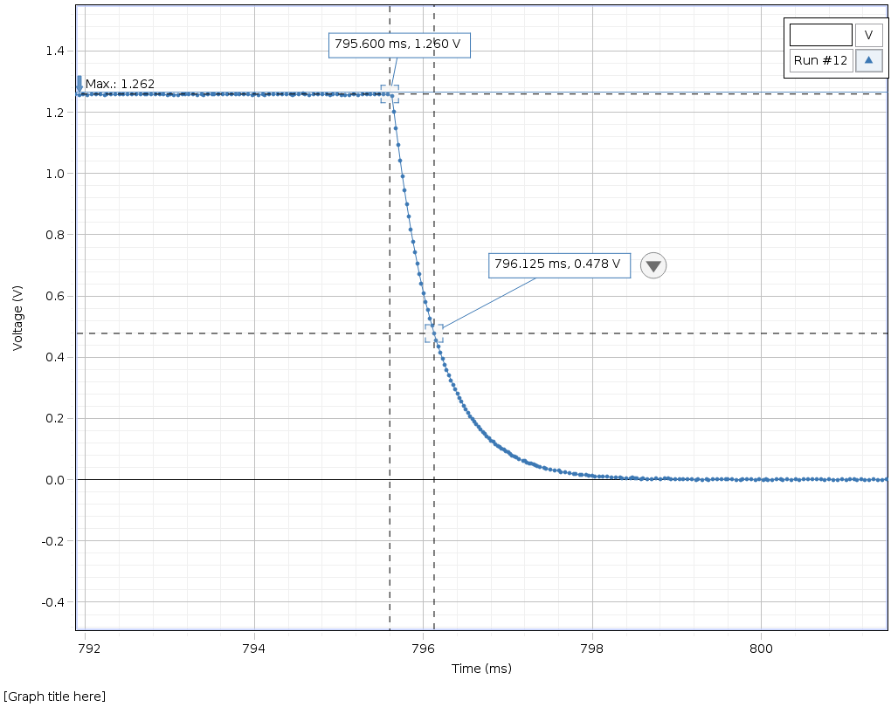Click record to begin. You will see what appears to be a square wave – until you zoom in.
2. Look at the decay of *V*: $V\left(t\right)=V_{0}e^{{-t}/τ}$ 
   . Need to define *t*0 as last *t*max time.
3. Experimental *τ* from   
   *t*max – *t*37%, using delta (crosshairs) tool. Drag along time axis to zoom in. Change units (click on s, change to ms) to get more significant digits.

Table 1 – AIR core

|  |  |  |  |  |  |
| --- | --- | --- | --- | --- | --- |
|  | Measure | Calculate | Measure | Measure | Calculate |
| Trial | $${ V}_{0}$$ | 0.37 ${ V}_{0}$ | Time at 0.37 $V_{0}$ | Time at last ${ V}_{0}$ value | ∆t = τ |
| 1 |  |  |  |  |  |
| 2 |  |  |  |  |  |
| 3 |  |  |  |  |  |
| average |  | NA | NA | NA |  |

Table 2 – IRON core

|  |  |  |  |  |  |
| --- | --- | --- | --- | --- | --- |
|  | Measure | Calculate | Measure | Measure | Calculate |
| Trial | $${ V}_{0}$$ | 0.37 ${ V}_{0}$ | Time at 0.37 $V_{0}$ | Time at last ${ V}_{0}$ value | ∆t = τ |
| 1 |  |  |  |  |  |
| 2 |  |  |  |  |  |
| 3 |  |  |  |  |  |
| average |  | NA | NA | NA |  |

1. To define *L* from *τ* we still need to find the resistance *r* of the coil. Disconnect your circuit from the signal generator and measure the resistance across the resistor AND the coil (*R*+*r* should equal about 15.6 Ohm total)

Using Ohm’s law find the peak current through the coil: $I_{0}=\frac{V_{0}}{(R)}$

Peak voltage $V_{0}$ can be taken from the previous tables.

|  |  |  |
| --- | --- | --- |
|  | AIR core | IRON core |
| $$V_{0}$$ |  |  |
| $$I_{0}$$ |  |  |
| *R*+*r* |  |  |

1. Now determine *L* for the solenoid filled with air and for the solenoid with the iron core using the equation: $L = τ (R+r)$  
   Knowing the inductance *L* allows evaluation of the magnetic energy stored in the coil using equation (4): $U_{M}=\frac{1}{2} L{ I}^{2}$

|  |  |
| --- | --- |
| *L*air |  |
| *Liron* |  |

|  |  |
| --- | --- |
| *Uair* |  |
| *Uiron* |  |

1. Compare magnetic energy stored in the coil with the iron core and without it.

For this, find the ratio of magnetic energy with the core to that without the core. This ratio will give you the relative magnetic permeability $μ_{r}$ for iron which shows the magnification of magnetic flux in the coil due to the iron core.

$$μ_{r}=\frac{U_{iron}}{U_{air}}=$$

**Check that all of your data has units specified.**

**Include conclusions and source of errors in your lab report.**